Q1.What is JPA?

JPA stands for Java Persistence API. Think of it as a set of guidelines or a blueprint for how Java objects should be stored and retrieved from a relational database. JPA is a specification—it tells you *what* you can do, but not *how* to do it. It defines things like annotations (@Entity, @Id, etc.) and interfaces, but it doesn’t provide any actual code to make things happen.

* Key Takeaways:
  + JPA is just a standard, not a library or tool.
  + You need a real implementation (like Hibernate) to use JPA in your project.
  + It helps keep your code database-agnostic and portable.

The Java Persistence API provides a specification for persisting, reading, and managing data from your Java object to relational tables in the database.

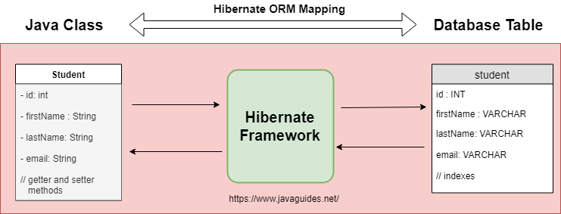

Q2.What is Hibernate?

Hibernate is where the magic happens! It’s the most popular implementation of the JPA specification. Hibernate takes the rules set by JPA and provides the actual code that interacts with your database. It handles the heavy lifting: opening connections, managing transactions, converting Java objects to database rows, and vice versa.

* Key Takeaways:
  + Hibernate is a real, working library (not just a set of rules).
  + It can be used directly (with its own APIs) or as a JPA provider.
  + You’ll often see Hibernate mentioned in job descriptions and project documentation.

Hibernate Implementation(Code):-

**public Integer addEmployee(Employee employee){**

**Session session = factory.openSession();**

**Transaction tx = null;**

**Integer employeeID = null;**

**try {**

**tx = session.beginTransaction();**

**employeeID = (Integer) session.save(employee);**

**tx.commit();**

**} catch (HibernateException e) {**

**if (tx != null) tx.rollback();**

**e.printStackTrace();**

**} finally {**

**session.close();**

**}**

**return employeeID;**

**}**

We are manually opening and closing sessions, starting and committing transactions, and handling exceptions yourself. It works, but it’s a lot of code for a simple task.

Q3.What is Spring Data JPA?

Spring Data JPA is like the “easy button” for working with JPA in Spring applications. It’s not an implementation of JPA, but rather a framework that sits on top of JPA providers (like Hibernate) and makes your life easier. With Spring Data JPA, you can write less code—just define interfaces, and Spring will generate the implementation for you at runtime.

* Key Takeaways:
  + Spring Data JPA reduces boilerplate code and simplifies data access.
  + It manages transactions for you and integrates perfectly with the Spring ecosystem.
  + You can focus on your business logic, not on repetitive CRUD code.

Spring Data JPA Implementation(Code):-

**EmployeeRepository.java:-**

public interface EmployeeRepository extends JpaRepository<Employee, Integer> { }

**EmployeeService.java**

@Autowired

private EmployeeRepository employeeRepository;

@Transactional

public void addEmployee(Employee employee) {

employeeRepository.save(employee);

}

In this we are just defining an interface, and Spring Data JPA gives you all the CRUD methods you need. No session or transaction management code required!